IQOE News #2
February 2019

IQOE continues its implementation activities and has made progress in several areas in the seven months since IQOE News #1 was distributed.

OceanObs’19—IQOE Science Committee members Jennifer Miksis-Olds and Hanne Sagen teamed with Bruce Howe, Eric Rehm, Peter F. Worcester, and Georgios Haralabus to lead the production of a community white paper for OceanObs’19 entitled “Observing the Oceans Acoustically”. This paper combines information about the use of both passive and active acoustics to study the global ocean. The paper has been submitted to Frontiers in Marine Science. A link to the paper will be added to the IQOE Website when it is available.

Please let Ed Urban know if you will be attending OceanObs’19. We are hoping for a good showing of people interested in observations of acoustics and bioacoustics in the ocean, and may plan some acoustics-focused event.

Ocean Sound Essential Ocean Variable (EOV)—The Biology and Ecosystems Panel of the Global Ocean Observing System (GOOS) has adopted an Ocean Sound EOV, under the responsibility of IQOE. An IQOE Panel supported by the Partnership for Observation of the Global Oceans (POGO) proposed this EOV and created the specification sheet. IQOE and GOOS are discussing next steps to progress this EOV, including the potential for an implementation meeting.

Aquatic Acoustic Archive: The Aquatic Acoustic Archive now makes available 4,559 records of papers relevant to IQOE. Many thanks to Christine Erbe of Curtin University for maintaining this database!

Intersections of Ocean Sensing with eDNA and Acoustics— Alison Watts and Jennifer Miksis-Olds produced a paper on “The Ocean as a Living Sensor: Environmental DNA and Acoustics for Detecting Marine Life” for the National Conference on Marine Environmental DNA that was held in New York City on 29-30 November 2018. The paper was stimulated by a meeting of the IQOE Strategy Group in August 2018.

Endorsed projects—Five projects have now been endorsed by IQOE:

- ADEON: Atlantic Deepwater Ecosystem Observatory Network
- JOMOPANS: Joint Monitoring Programme for Ambient Noise North Sea
- JONAS: A Joint program for Ocean Noise in the Atlantic Seas
- PHYSIC: Ports, Humpbacks, Y Soundscapes In Colombia
- TANGO: Rerouting shipping lanes in the Kattegat – effects on soundscape and ecosystem

IQOE would like to endorse any research project or observation activities that are relevant to IQOE. Information about the endorsement process and endorsed projects can be found at http://www.iqoe.org/projects. The benefits of endorsement include increased international visibility of endorsed projects, which are usually national or regional, and the potential for joint activities with other endorsed projects and with other IQOE-involved scientists
Requests for Inputs to IQOE Website: We still need help from the community to do the following (send update information to Ed Urban at ed.urban@scor-int.org):

- update the database of passive acoustic observatories (https://iqoe.org/systems),
- submit IQOE-relevant papers for the IQOE literature database (https://iqoe.org/library)
- submit entries for the portal to acoustic data (https://iqoe.org/acoustic-data-portal)
- submit entries for the portal to marine animal sounds (https://iqoe.org/marine-animal-sounds), and
- submit projects for endorsement.

WG Progress—IQOE currently supports four working groups, each of which has made progress since June:

- WG on Acoustic Measurement of Ocean Biodiversity Hotspots (chaired by Aran Mooney, USA): The group is working on a “perspectives” paper on the use of passive acoustics to assess and monitor diversity of marine life. The group also explored the issue of how to help with the identification of unknown sounds made by marine organisms, through an on-line portal, publication, or some other approach.
- WG on Arctic Acoustic Environment (co-chaired by Hanne Sagen, Norway and Philippe Blondel, UK): The group met for the first time in Paris, France on 29-30 January 2019 and identified actions to implement the group’s terms of reference.
- WG on Data Management and Access (chaired by Rob McCauley, Australia): members of this group have held two conference calls and are discussing with the IQOE Science Committee the requirements for IQOE data management.
- WG on Standardization (co-chaired by Christ de Jong and Michael Ainslie, Netherlands): this group has created an Inventory of Existing Standards for Observations of Sound in the Ocean.

Capacity Building—The Scientific Committee on Oceanic Research (SCOR), one of IQOE’s sponsors, supported the participation of two students from Brazil to participate in the SeaBASS Summer School on 8-13 July 2018 at the University of New Hampshire. IQOE is exploring the possibility of holding an international summer school on IQOE-related topics in 2021. This summer school would be designed to be complementary to the SeaBASS Summer School.

National/Regional Activities
- Europe: The IQOE-endorsed TANGO project was approved. This project in the Baltic Sea will study the effects of heavy ship traffic in a shallow sea, by examining changes that occur with re-routing of shipping lanes in this area. A range of parameters will be measured in the existing shipping lane, the new shipping lane, and reference areas away from the shipping lanes. This will be done for at least a full year prior to rerouting, to establish a baseline, and at least one full year after the change.
- Columbia: The Ports, Humpbacks, Y Soundscapes In Colombia (PHYSIC) project has completed its first year of soundscape surveys along the west coast of Colombia, in preparation for construction of a new port in the area in 2020. The project is focused on focused on effects on humpback whales, but has also been able to collect data on other sound sources.

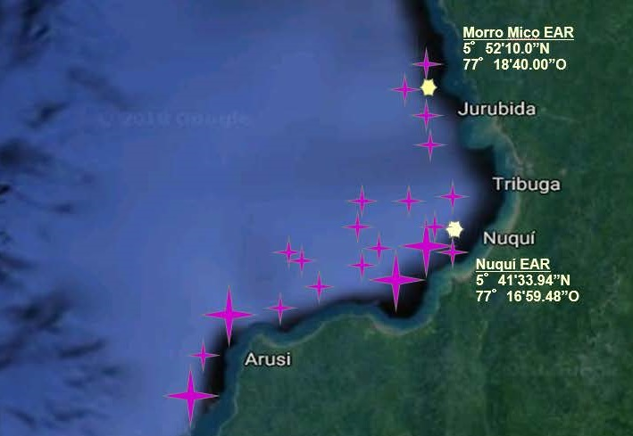
Sampling conducted and planned by PHYSIC off the west coast of Colombia. White stars are the locations of EARs and purple stars are the locations of over-the side recordings already made.

- UK: The Underwater Sound Forum will hold a Bioacoustics Conference on 17-18 April 2019.
- USA: The U.S. Quiet Ocean Project held a data “standards” workshop on 6-7 August 2018 in Washington, D.C. and has released a report from the workshop on Recommendations Related to Passive Ocean Acoustic Data Standards.

Stimulated by recommendations from IQOE, the Gulf Research Program of the National Academy of Sciences, Engineering and Medicine invested in a passive acoustic sensor package in tandem with the Shell Stones mooring designed to monitor conditions at the Stones location and Loop Current processes. The acoustic sensors will be deployed at 1000m depth in the Gulf of Mexico.

The IQOE-endorsed ADEON project (https://adeon.unh.edu/) has completed three cruises for deployment and recovery of bottom landers so far, with a fourth cruise scheduled for November 2019. ADEON is well into its Phase IV, making significant progress on managing and serving data from the project (see https://adeon.unh.edu/data_portal).

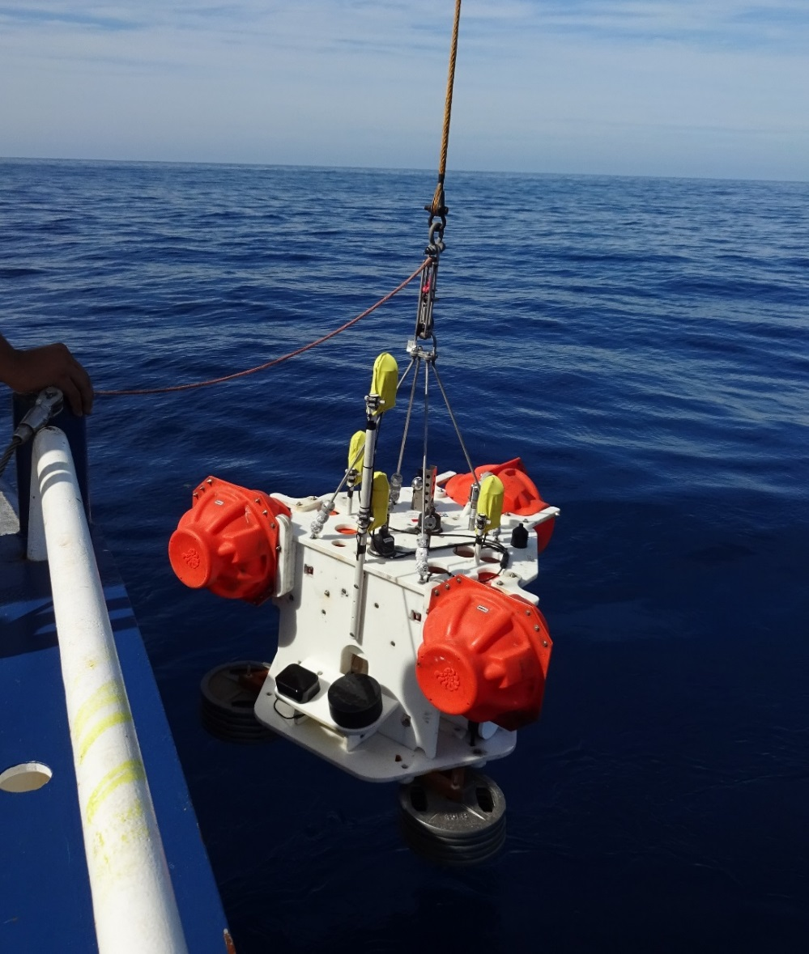
Deployment of ADEON Bottom Lander

IQOE Email List: IQOE maintains an email list containing your first name, surname, and email address. We do not collect or store any additional information or share our email list with other organizations. If you wish to unsubscribe from the IQOE email list at any time, please click the “Unsubscribe” link at the bottom of this page.

OceanObs’19 Meeting —IQOE is planning a variety of activities at the OceanObs’19 Meeting in Honolulu, Hawaii in September 2019.

Upcoming Meetings—New meetings have been added to the calendar of IQOE-relevant events.

