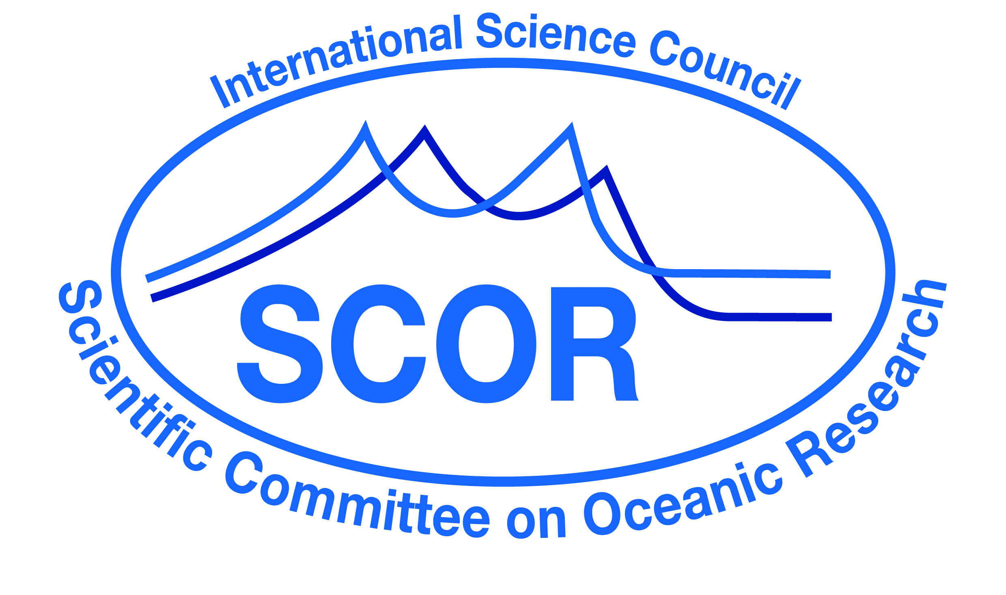

Call for 2023 SCOR Visiting Scholars

For more than a decade, SCOR has supported Ph.D. level ocean scientists from developed and developing countries to teach short courses and provide extended on-site education and mentorship at developing country institutions (see list here). These scholarships are not intended to directly support research, although collaborative research may be an outcome of a visit. The overarching goal of this program is to inspire, motivate, and inform students and faculty at developing institutions while also building long-term and sustainable collaborations and capacity. More than 40 scientists have participated in the program with host institutions in more than 25 countries. A list of past SCOR Visiting Scholars can be found here.

The SCOR Visiting Scholars Program is a partnership between SCOR and local hosts. SCOR provides up to $2,500 for airfare and local expenses for each fellow; local hosts often provide local accommodation and may support some other local expenses. Local support from host institutions demonstrates institutional commitment to the visit. The participating scientists donate their time and ideally must be onsite for a minimum of two weeks but are encouraged to stay as long as visa requirements allow and hosts are willing to provide accommodation. Applications from all regions of the world are welcome and the visit can happen at any time between February 2023 and December 2023.

Awards for these individual scholarships are very competitive and the number of scientists placed each year will depend on the number of applications received and available funding. The program has awarded scholarships to scientists at all career levels, from early career scientists to emeritus professors. As the purpose of the program is teaching and mentoring, extensive experience in these areas is strongly preferred. Such experience should be highlighted in the application along with specifics regarding knowledge exchange plans and actions.

SCOR will select Scholars through its Committee on Capacity Development, which will review the applications and the proposed work assignments at the host institutions. Criteria for selection will include the following:
- Quality and relevance of the proposal focusing on knowledge exchange and mentoring
- A detailed working plan for the visit which should be co-developed with the host institution
- Experience of the candidate and fit with the program (language skills, teaching/mentoring experience, subject areas requested by the institution)
- Needs of the host institution and an estimate of how many students and/or early career scientists will benefit from the training
- Plans by the host institution to build upon the training/mentoring received

The individual SCOR Visiting Scholar and the host institution will be responsible for ensuring a successful outcome. SCOR will monitor the results of each partnership with a questionnaire to the visiting scientist and the host institution after the visit to monitor the effectiveness of the program and make improvements as needed. SCOR is aware that the COVID crisis may impose changes or adaptation of approved plans.

Report from Completed Scholar Visits
Following completion of a SCOR Visiting Scholar’s term, the Scholar is required to submit a timely report to SCOR. This report should describe the experience and outcomes of the visit, recommendations to SCOR for future implementation of the Visiting Scholar program, and potential for future interactions with the host institution. Scholars will also be requested to respond to a short survey after their assignments.

Applications for the 2023 SCOR Visiting Scholars Program should be sent to patricia.miloslavich@scor-int.org by 23 December 2022 (up to 23:59 UTC).

The application package must include:
-A completed application (see template in the next pages)
-A short 3-page CV of the applicant
-A letter of endorsement by the contact person at the host institution

For more information read about the SCOR Visiting Scholar at the SCOR website:
https://scor-int.org/work/capacity/visiting-scholars/

Application for SCOR Visiting Scholars
(Submit by 23 December 2022)

Information to be completed by the SCOR Visiting Scholar applicant

Name and contact information of applicant

Experience in teaching and mentoring (one summary paragraph of 500 words maximum, plus a short CV of no more than 3 pages)

Languages spoken and written fluently—while many institutions in developing countries seek scientific instruction in English to help prepare them to interact with scientists from the global ocean science community, some knowledge of the national language may be helpful.

Visit plan: e.g. teaching, mentoring in research, technology assistance, etc., as required by the host institution. Include how the impact of the training will be evaluated (maximum 600 words)

Host institution (country) and contact person at host institution (An invitation letter with the information requested in the following section should be provided)

Estimated date of visit, and total estimated number of activity hours (e.g. in teaching, mentoring, technology assistance)

Coverage by health and accident insurance—Lack of coverage would not rule out any candidate but would alert SCOR to the need to arrange such insurance.

Information to be completed by the Host Institutions of SCOR Visiting Scholars

Institutions hosting a SCOR Visiting Scholar should provide the following information in relation to the visiting scientist’s term at the host institution:

Name and contact information of host

Local subsistence that will be provided by the host institution (e.g. lodging, food, transportation, etc.)

Estimated number of students and/or scientists and career level that will benefit from the training

Plans by the host institution to build on the training received, especially developing mechanisms for longer-term engagement between the Visiting Scholar and graduate students. Examples may include reciprocal visits by the students trained, becoming members of host institution graduate committees, etc. (500 words maximum)

The host must provide a letter endorsing the application of the Visiting Scholar. The host must also agree to conduct an evaluation of the effectiveness of the Visiting Scholar’s visit, using a survey provided by SCOR. This survey should be conducted by the host institution before the end of the Visiting Scholar’s visit.

Yes, I agree to conduct the SCOR survey

